How to Install the Theme (Properly)

**Important: This theme is meant for the latest version of Attorney Online at the time of this theme made, 2.9-2.9.1! Trying to use this theme on clients lower than that may cause the theme to break or your client to break, so do not install this theme unless your client is up to 2.9-2.9.1!**

**IMPORTANT NOTE for V1.1: If you have installed the otf version of the fonts, you need to manually uninstall all the fonts and reinstall them in settings! Not replacing the otf fonts with the ttf fonts will make the theme look off if you don’t do it.**



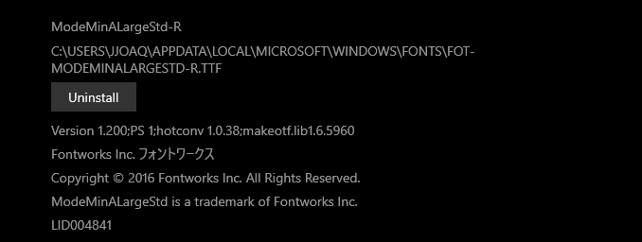

In order to download the theme, You’ll need to first unzip the theme.



Next, you’ll need to drag the base folder (this one):



And drag to the client you’re using. Example of a client:



Afterwards, you should go to base>fonts>and into the theme you just put in.



There will be four fonts you’ll first need to install, look for files that look like this:

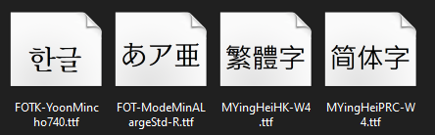

Click on them and you’ll be prompted to print or install. Click on install.

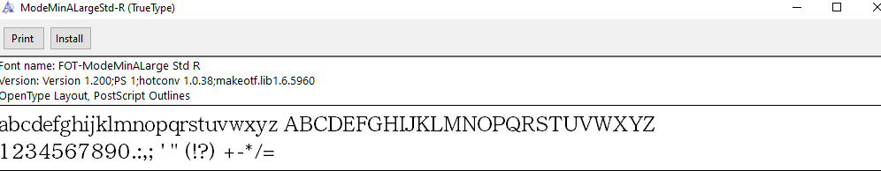

After installing both fonts, you can now use the theme!

To select theme, click on settings when you get into the lobby and go the theme menu drop down:

Select “AOHDDarkMini” and now you’ll have that as your theme in AO! Enjoy.